PYTHON PROGRAMS
AIM • PROCEDURE • FLOWCHART • PROGRAM • OUTPUT
Practical Record
Note: The outputs shown are sample runs using the sample input values printed in each section. Actual output changes according to the values entered by the user.

PROGRAM 1: Salary Calculation and Deduction

AIM
Calculate gross salary from basic salary, allowances, overtime and incentives. Apply deductions based on the gross salary slab and find net salary.

PROCEDURE
- Input basic salary, allowances, overtime and incentives
- Calculate gross salary
- Check gross salary slab
- Calculate deduction (5%, 10% or 15%)
- Calculate net salary
- Display basic, gross, deduction and net salary

FLOWCHART
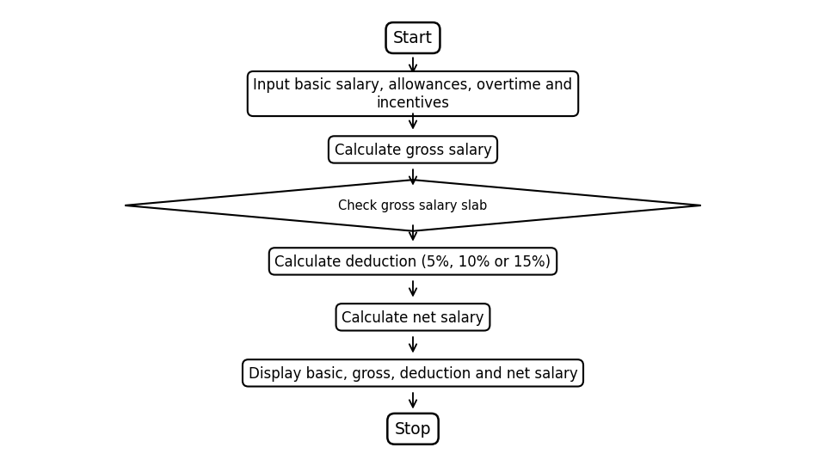

PROGRAM
basic = float(input("Enter basic salary: "))
allowances = float(input("Enter allowances: "))
overtime = float(input("Enter overtime amount: "))
incentives = float(input("Enter incentives: "))
gross = basic + allowances + overtime + incentives
if gross <= 20000:
deduction = gross * 0.05
elif gross <= 40000:
deduction = gross * 0.10
else:
deduction = gross * 0.15
net = gross - deduction
print("basic Salary:", basic)
print("gross Salary:", gross)
print("deduction:", deduction)
print("net Salary:", net)

OUTPUT (SAMPLE)
Enter basic salary: 15000
Enter allowances: 3000
Enter overtime amount: 1000
Enter incentives: 1000
basic Salary: 15000.0
gross Salary: 20000.0
deduction: 1000.0
net Salary: 19000.0

PROGRAM 2: Mobile Data Plan Eligibility

AIM
Check each mobile plan against the user's budget, required data and minimum validity of 28 days.

PROCEDURE
- Input number of plans, budget and required data
- Repeat for each plan
- Input plan price, data limit and validity
- Check: data >= required, validity >= 28 and price <= budget
- Display eligible plan details or not eligible

FLOWCHART
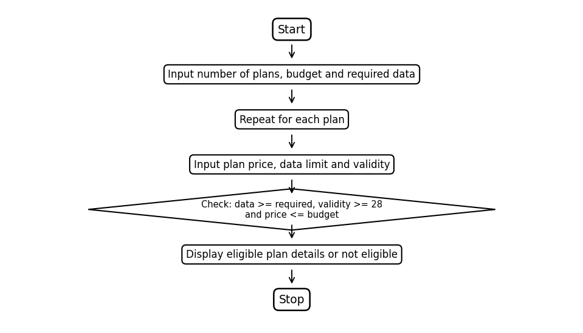

PROGRAM
n = int(input("Enter number of plans: "))
budget = int(input("Enter your budget: "))
usage = int(input("Enter required data in GB: "))
for i in range(n):
print("Plan", i + 1)
price = int(input("Enter plan price: "))
data = int(input("Enter data limit in GB: "))
validity = int(input("Enter validity in days: "))
if data >= usage and validity >= 28 and price <= budget:
print("eligible plan")
print("plan price:", price)
else:
print("not eligible")

OUTPUT (SAMPLE)
Enter number of plans: 2
Enter your budget: 300
Enter required data in GB: 2
Plan 1
Enter plan price: 249
Enter data limit in GB: 2
Enter validity in days: 28
eligible plan
plan price: 249
Plan 2
Enter plan price: 399
Enter data limit in GB: 3
Enter validity in days: 56
not eligible

PROGRAM 3: Vehicle Fuel Consumption and Route Cost

AIM
Calculate fuel required and journey cost for each vehicle, including reserve fuel, and identify the lowest journey cost.

PROCEDURE
- Input number of vehicles, distance and reserve fuel
- Set lowest cost to 0
- Repeat for each vehicle
- Input mileage and fuel price
- Calculate fuel = distance / mileage + reserve
- Calculate journey cost = fuel x fuel price
- Display fuel needed and journey cost
- Update lowest cost if needed
- Display lowest cost

FLOWCHART
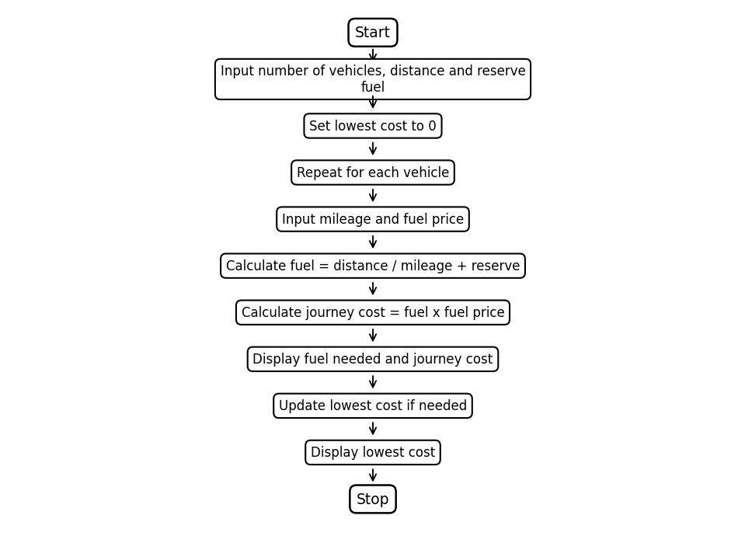

PROGRAM
n = int(input("Enter number of vehicles: "))
distance = int(input("Enter distance: "))
reserve = int(input("Enter reserve fuel: "))
low = 0
for i in range(n):
mileage = int(input("Enter mileage: "))
price = int(input("Enter fuel price: "))
fuel = distance / mileage
fuel = fuel + reserve
cost = fuel * price
print("fuel needed:", fuel)
print("journey cost:", cost)
if low == 0 or cost < low:
low = cost
print("lowest cost:", low)

OUTPUT (SAMPLE)
Enter number of vehicles: 2
Enter distance: 100
Enter reserve fuel: 2
Enter mileage: 20
Enter fuel price: 100
fuel needed: 7.0
journey cost: 700.0
Enter mileage: 25
Enter fuel price: 100
fuel needed: 6.0
journey cost: 600.0
lowest cost: 600.0

PROGRAM 4: Product Billing with Discount and Tax

AIM
Calculate each product bill using price and quantity, apply a fixed discount when the amount is at least 1000, add 5% tax and calculate the total bill.

PROCEDURE
- Input number of products and set total to 0
- Repeat for each product
- Input price and quantity
- Calculate amount = price x quantity
- If amount >= 1000, discount = 100; otherwise discount = 0
- Calculate tax = 5% of amount
- Calculate bill = amount + tax - discount
- Display product bill and add it to total
- Display total bill

FLOWCHART
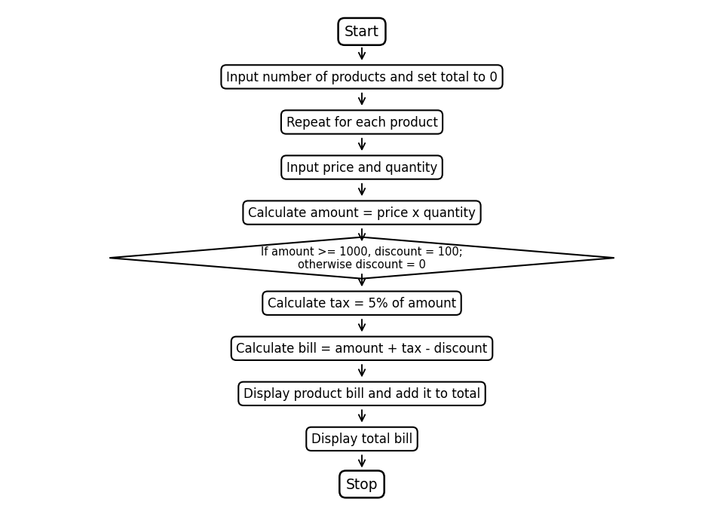

PROGRAM
n = int(input("Enter number of products: "))
total = 0
for i in range(n):
price = int(input("Enter price: "))
quantity = int(input("Enter quantity: "))
amount = price * quantity
if amount >= 1000:
discount = 100
else:
discount = 0
tax = amount * 0.05
bill = amount + tax - discount
print("product bill:", bill)
total = total + bill
print("total bill:", total)

OUTPUT (SAMPLE)
Enter number of products: 2
Enter price: 500
Enter quantity: 2
product bill: 950.0
Enter price: 200
Enter quantity: 3
product bill: 630.0
total bill: 1580.0

PROGRAM 5: Production Cost and Profit Target

AIM
Find total production cost and profit, then check whether the profit reaches the given target.

PROCEDURE
- Input material, labour, wastage and machine costs
- Input selling price and profit target
- Calculate total cost
- Calculate profit = selling price - total cost
- Display total cost and profit
- Check whether profit >= target
- Display target achieved or not achieved

FLOWCHART
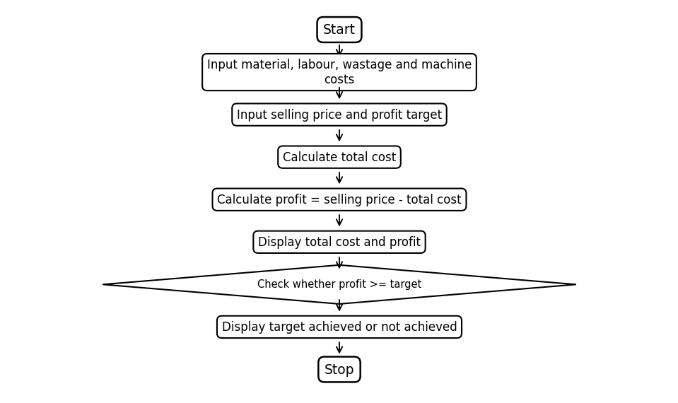

PROGRAM
material = int(input("Enter material cost: "))
labour = int(input("Enter labour charges: "))
wastage = int(input("Enter wastage cost: "))
machine = int(input("Enter machine cost: "))
selling = int(input("Enter selling price: "))
target = int(input("Enter profit target: "))
cost = material + labour + wastage + machine
profit = selling - cost
print("total cost:", cost)
print("profit:", profit)
if profit >= target:
print("profit target achieved")
else:
print("profit target not achieved")

OUTPUT (SAMPLE)
Enter material cost: 500
Enter labour charges: 200
Enter wastage cost: 50
Enter machine cost: 100
Enter selling price: 1000
Enter profit target: 100
total cost: 850
profit: 150
profit target achieved

PROGRAM 6: Event Budget and Minimum Registrations

AIM
Calculate total event cost and remaining amount after sponsorship. Find the minimum registrations needed to cover the remaining amount using the registration fee.

PROCEDURE
- Input venue, food and transport costs
- Calculate total cost
- Input sponsorship and registration fee
- Calculate balance = total cost - sponsorship
- Check fee > 0 and balance > 0
- Calculate required registrations using ceiling division
- Display total cost, remaining amount and minimum registrations

FLOWCHART
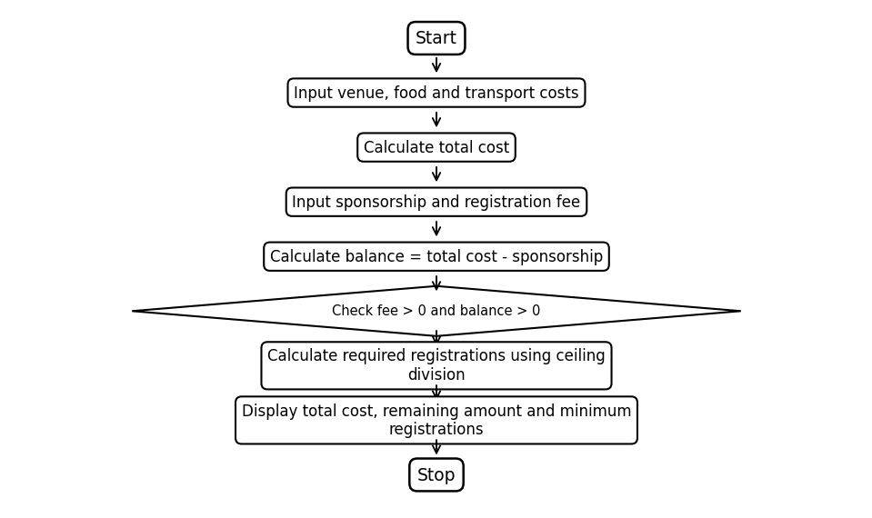

PROGRAM
venue = int(input("Enter venue cost: "))
food = int(input("Enter food cost: "))
transport = int(input("Enter transport cost: "))
total = venue + food + transport
sponsor = int(input("Enter sponsorship amount: "))
fee = int(input("Enter registration fee per person: "))
balance = total - sponsor
print("total cost:", total)
print("remaining amount:", balance)
if fee > 0 and balance > 0:
count = balance // fee
if balance % fee != 0:
count = count + 1
else:
count = 0
print("minimum registrations:", count)

OUTPUT (SAMPLE)
Enter venue cost: 5000
Enter food cost: 3000
Enter transport cost: 2000
Enter sponsorship amount: 4000
Enter registration fee per person: 300
total cost: 10000
remaining amount: 6000
minimum registrations: 20

PROGRAM 7: Student Attendance Eligibility

AIM
Calculate current attendance percentage and determine eligibility. If attendance is below the target, calculate the minimum additional classes needed to reach it.

PROCEDURE
- Input attended classes, total classes and target percentage
- Calculate attendance percentage
- Display current attendance
- Check percentage >= target
- If yes, display eligible
- Otherwise, repeat adding one attended class and one total class until target is reached
- Display minimum extra classes required

FLOWCHART
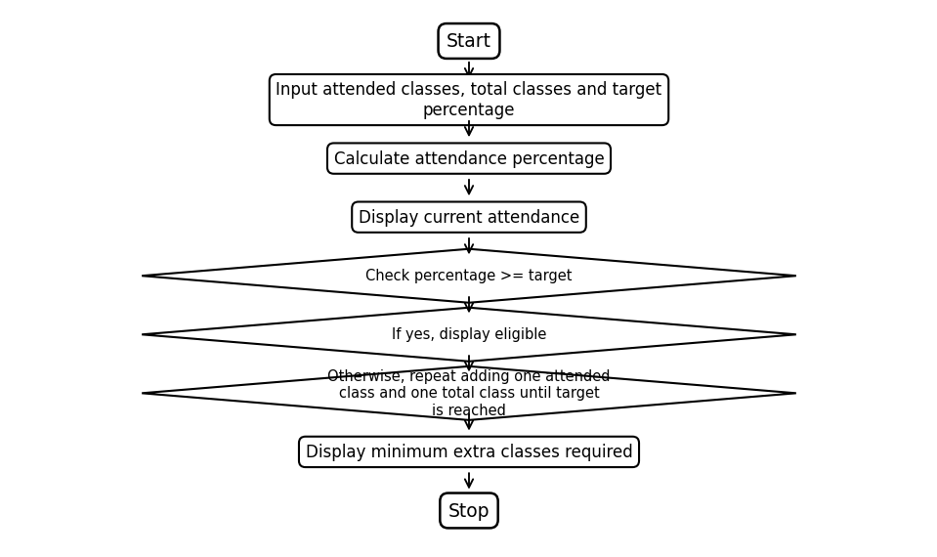

PROGRAM
attended = int(input("Enter attended classes: "))
total = int(input("Enter total classes: "))
target = int(input("Enter required attendance: "))
percentage = attended / total * 100
print("current attendance:", percentage)
if percentage >= target:
print("eligible")
else:
extra = 0
while percentage < target:
attended = attended + 1
total = total + 1
extra = extra + 1
percentage = attended / total * 100
print("minimum extra classes required:", extra)

OUTPUT (SAMPLE)
Enter attended classes: 40
Enter total classes: 50
Enter required attendance: 75
current attendance: 80.0
eligible

PROGRAM 8: Bank Deposit and Withdrawal Transactions

AIM
Process a series of deposit and withdrawal transactions, validate amounts and withdrawal limits, and display the final balance.

PROCEDURE
- Set initial balance to 1000
- Input number of transactions
- Repeat for each transaction
- Display deposit and withdraw choices
- Input choice and amount
- Validate amount > 0
- For deposit, add amount to balance
- For withdrawal, check amount <= balance and amount <= 5000
- Update balance or reject transaction
- Display final balance

FLOWCHART
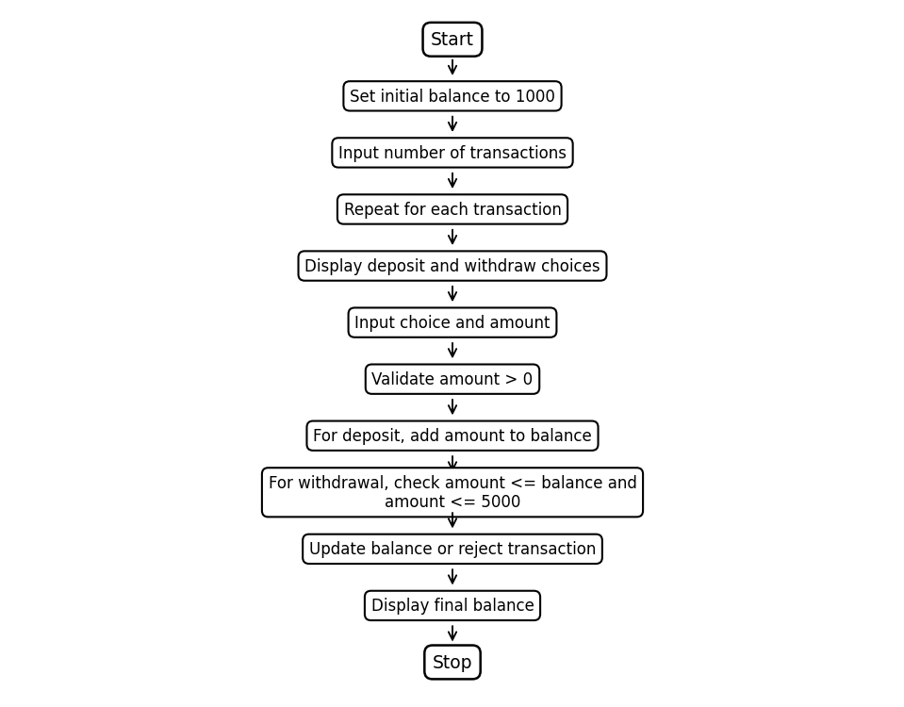

PROGRAM
balance = 1000
n = int(input("Enter number of transactions: "))
for i in range(n):
print("1. deposit")
print("2. withdraw")
choice = int(input("Enter choice: "))
amount = int(input("Enter amount: "))
if amount <= 0:
print("invalid amount")
elif choice == 1:
balance = balance + amount
print("deposit successful")
elif choice == 2:
if amount <= balance and amount <= 5000:
balance = balance - amount
print("withdrawal successful")
else:
print("transaction rejected")
else:
print("invalid choice")
print("final balance:", balance)

OUTPUT (SAMPLE)
Enter number of transactions: 3
1. deposit
2. withdraw
Enter choice: 1
Enter amount: 500
deposit successful
1. deposit
2. withdraw
Enter choice: 2
Enter amount: 200
withdrawal successful
1. deposit
2. withdraw
Enter choice: 2
Enter amount: 2000
transaction rejected
final balance: 1300

PROGRAM 9: Parking Fee Calculation

AIM
Calculate parking duration and fee from entry and exit hours. Handle overnight parking and cap the fee at 200.

PROCEDURE
- Input entry hour and exit hour (0-23)
- Check whether either time is outside 0-23
- If invalid, display invalid time
- If exit < entry, calculate overnight hours
- Otherwise calculate normal hours
- Calculate fee = hours x 20
- If fee > 200, set fee to 200
- Display parking fee

FLOWCHART
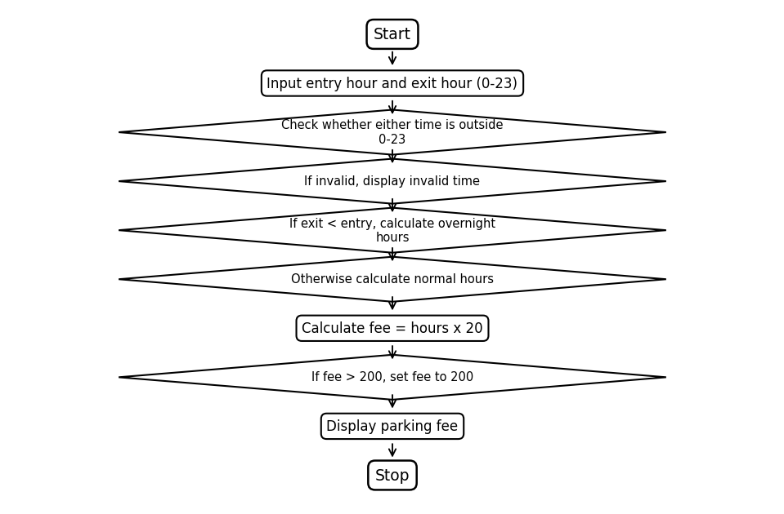

PROGRAM
entry = int(input("Enter entry hour (0-23): "))
exit = int(input("Enter exit hour (0-23): "))
if entry < 0 or entry > 23 or exit < 0 or exit > 23:
print("invalid time")
elif exit < entry:
print("overnight parking")
hours = 24 - entry + exit
fee = hours * 20
if fee > 200:
fee = 200
print("parking fee:", fee)
else:
hours = exit - entry
fee = hours * 20
if fee > 200:
fee = 200
print("parking fee:", fee)

OUTPUT (SAMPLE)
Enter entry hour (0-23): 22
Enter exit hour (0-23): 2
overnight parking
parking fee: 80

PROGRAM 10: Hospital Billing and Patient Classification

AIM
Calculate each patient's bill from consultation, diagnostic and treatment charges. Reject negative totals, apply a 10% concession for bills of at least 5000, and classify the final bill as low, medium or high.

PROCEDURE
- Input number of patients
- Repeat for each patient
- Input consultation, diagnostic and treatment charges
- Calculate total bill
- If total < 0, display invalid bill
- If total >= 5000, apply 10% concession
- Display final bill
- Classify: <= 2000 low; <= 5000 medium; otherwise high

FLOWCHART
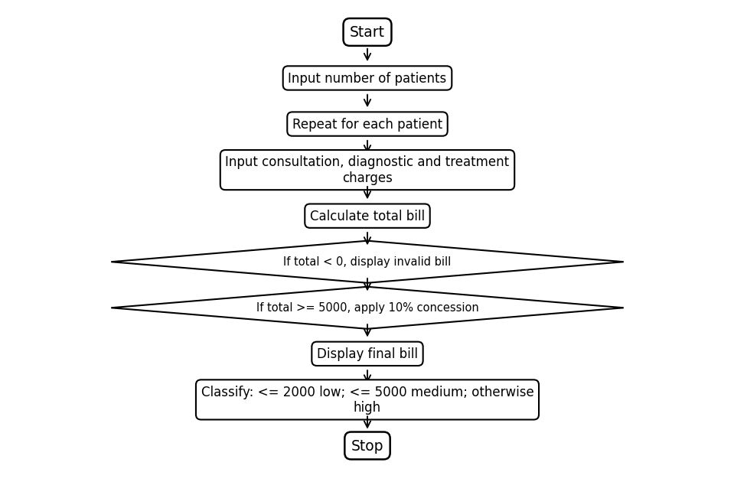

PROGRAM
n = int(input("patients: "))
for i in range(n):
c = int(input("consultation: "))
d = int(input("diagnostic: "))
t = int(input("treatment: "))
total = c + d + t
if total < 0:
print("invalid bill")
else:
if total >= 5000:
total = total * 0.9
print("bill:", total)
if total <= 2000:
print("low")
elif total <= 5000:
print("medium")
else:
print("high")

OUTPUT (SAMPLE)
patients: 2
consultation: 500
diagnostic: 300
treatment: 700
bill: 1500
low
consultation: 2000
diagnostic: 1500
treatment: 2500
bill: 5400.0
high

